Magnetic Hysteresis Loop (B-H Curve):
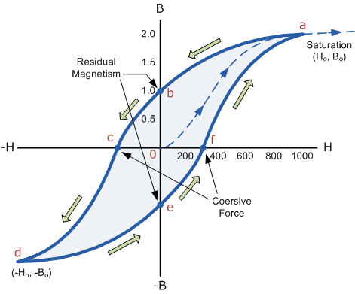

The Magnetic Hysteresis loop above, shows the behaviour of a ferromagnetic core graphically as the relationship between B and H is non-linear. Starting with an unmagnetised core both B and H will be at zero, point 0 on the magnetisation curve.
If the magnetisation current, i is increased in a positive direction to some value the magnetic field strength H increases linearly with i and the flux density B will also increase as shown by the curve from point 0 to point a as it heads towards saturation.
Now if the magnetising current in the coil is reduced to zero, the magnetic field circulating around the core also reduces to zero. However, the coils magnetic flux will not reach zero due to the residual magnetism present within the core and this is shown on the curve from point a to point b.
To reduce the flux density at point b to zero we need to reverse the current flowing through the coil. The magnetising force which must be applied to null the residual flux density is called a “Coercive Force”. This coercive force reverses the magnetic field re-arranging the molecular magnets until the core becomes unmagnetised at point c.
An increase in this reverse current causes the core to be magnetised in the opposite direction and increasing this magnetisation current further will cause the core to reach its saturation point but in the opposite direction, point d on the curve.
This point is symmetrical to point b. If the magnetising current is reduced again to zero the residual magnetism present in the core will be equal to the previous value but in reverse at point e.
Again reversing the magnetising current flowing through the coil this time into a positive direction will cause the magnetic flux to reach zero, point f on the curve and as before increasing the magnetisation current further in a positive direction will cause the core to reach saturation at point a.
Then the B-H curve follows the path of a-b-c-d-e-f-a as the magnetising current flowing through the coil alternates between a positive and negative value such as the cycle of an AC voltage. This path is called a Magnetic Hysteresis Loop.
The effect of magnetic hysteresis shows that the magnetisation process of a ferromagnetic core and therefore the flux density depends on which part of the curve the ferromagnetic core is magnetised on as this depends upon the circuits past history giving the core a form of “memory”. Then ferromagnetic materials have memory because they remain magnetised after the external magnetic field has been removed.
However, soft ferromagnetic materials such as iron or silicon steel have very narrow magnetic hysteresis loops resulting in very small amounts of residual magnetism making them ideal for use in relays, solenoids and transformers as they can be easily magnetised and demagnetised.
Since a coercive force must be applied to overcome this residual magnetism, work must be done in closing the hysteresis loop with the energy being used being dissipated as heat in the magnetic material. This heat is known as hysteresis loss (energy loss), the amount of loss depends on the material’s value of coercive force.
By adding additive’s to the iron metal such as silicon, materials with a very small coercive force can be made that have a very narrow hysteresis loop. Materials with narrow hysteresis loops are easily magnetised and demagnetised and known as soft magnetic materials.

Magnetic Hysteresis Loops for Soft and Hard Materials:
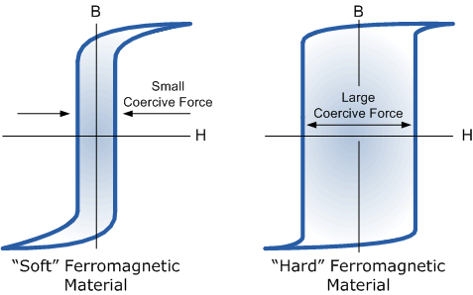

Magnetic Hysteresis results in the dissipation of wasted energy in the form of heat with the energy wasted being in proportion to the area of the magnetic hysteresis loop. Hysteresis losses will always be a problem in AC transformers where the current is constantly changing direction and thus the magnetic poles in the core will cause losses because they constantly reverse direction.
Rotating coils in DC machines will also incur hysteresis losses as they are alternately passing north the south magnetic poles. As said previously, the shape of the hysteresis loop depends upon the nature of the iron or steel used and in the case of iron which is subjected to massive reversals of magnetism, for example transformer cores, it is important that the B-H hysteresis loop is as small as possible.

Retentivity and Coercivity:
Let’s assume that we have an electromagnetic coil with a high field strength due to the current flowing through it, and that the ferromagnetic core material has reached its saturation point, maximum flux density. If we now open a switch and remove the magnetizing current flowing through the coil we would expect the magnetic field around the coil to disappear as the magnetic flux reduced to zero.
However, the magnetic flux does not completely disappear as the electromagnetic core material still retains some of its magnetism even when the current has stopped flowing in the coil. This ability for a coil to retain some of its magnetism within the core after the magnetisation process has stopped is called Retentivity or remanence, while the amount of flux density still remaining in the core is called Residual Magnetism, B_{R}.
The reason for this that some of the tiny molecular magnets do not return to a completely random pattern and still point in the direction of the original magnetising field giving them a sort of “memory”. Some ferromagnetic materials have a high retentivity (magnetically hard) making them excellent for producing permanent magnets.
While other ferromagnetic materials have low retentivity (magnetically soft) making them ideal for use in electromagnets, solenoids or relays. One way to reduce this residual flux density to zero is by reversing the direction of the current flowing through the coil, thereby making the value of H, the magnetic field strength negative. This effect is called a Coercive Force, H_{C} .

